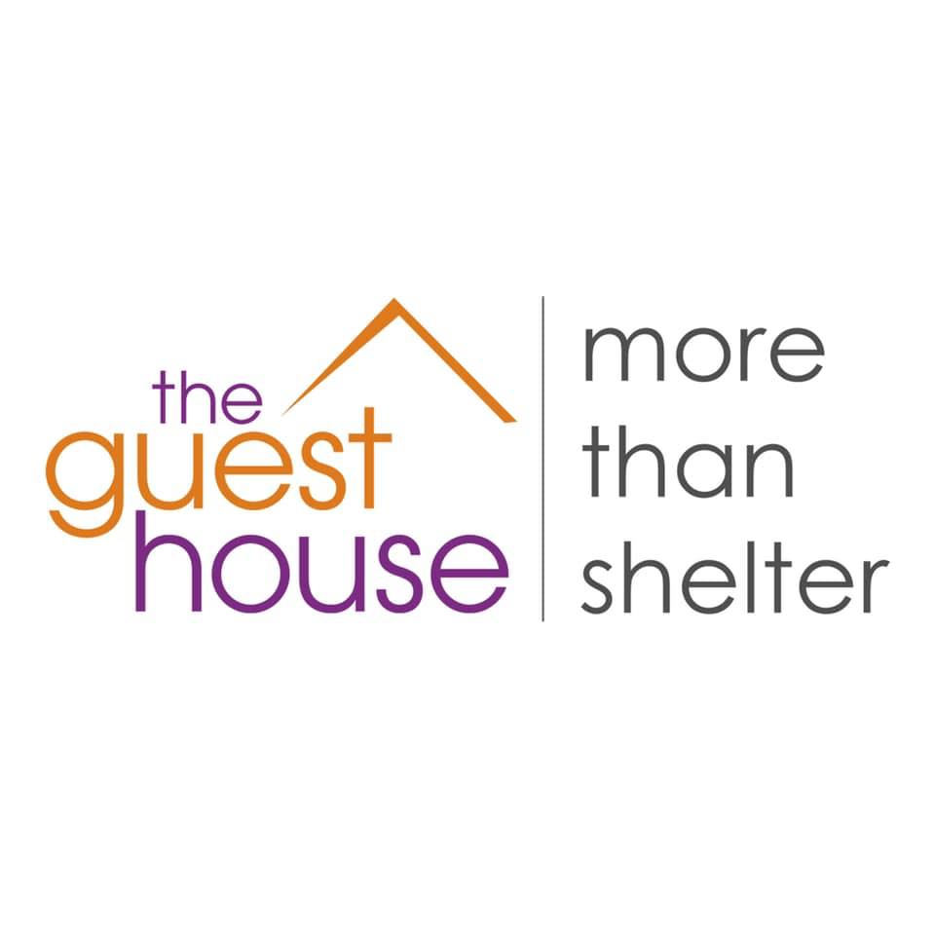

DIY Fundraiser & Donation Drive Guide
Created: February 20, 2020

Thank you for your interest in supporting Guest House of Milwaukee through a do-it-yourself fundraiser. This brief guide will provide all the information you need to determine if a DIY fundraiser is right for you and, if so, the process to get started.

If you have any questions along the way, please contact:

Coordinate & schedule a donation drive:
Alyssa Cabreza
Fund Development Coordinator
414-881-8216
alyssacabreza@guesthouseofmilwaukee.org

Volunteer opportunities:
Siena Morrisey
Manager of Fund Development
414-316-2025
siena@guesthouseofmilwaukee.org

Media engagement & auction/raffle inclusion:
Amy Rowell
Director of Fund Development
414-316-2012
amy@guesthouseofmilwaukee.org

The mission of Guest House of Milwaukee is to provide shelter, housing, education, and services to Milwaukee’s homeless who seek to transform their lives with dignity and purpose.

Guest House of Milwaukee
1216 North 13th Street
Milwaukee, WI 53205
www.guesthouseofmilwaukee.org
SECTION ONE: DIY FUNDRAISERS

What is a DIY fundraiser?
DIY fundraisers are organized by community volunteers to benefit Guest House of Milwaukee. Staff is available to provide support as well as printed agency materials and signage. Staff may also incorporate promotion within communications, whenever possible and appropriate. By request, a staff member will attend an event or meeting to express gratitude and deliver brief remarks.

What will my DIY fundraiser support?
You can designate your funds to support a specific program or general operating. By request, staff will provide a current list of funding and in-kind needs. You can also use your collected funds to purchase and donate items from the wish list.

Is Guest House of Milwaukee permission required to host a DIY fundraiser?
Permission is not required but it is preferred. DIY fundraisers should be aligned with the mission of Guest House of Milwaukee with meaningful and realistic goals, supported by a project plan. Staff is available to assist in the development of a project plan, by request. All promotional materials that include Guest House of Milwaukee’s name and/or logo require approval prior to distribution.

Please visit https://www.guesthouseofmilwaukee.org/diy for more information and to download a promotional template, approved photos, and logos.

What should the project plan include?
The project plan can be as simple or as complicated as you’d like but should include the following:
- Date(s)
- Location
- Planning committee members
- Budget (Guest House of Milwaukee is unable to cover costs outside of staff time and printed agency materials and signage.)
- Fundraising goal
- Tasks and corresponding assignments with timeline

Can I solicit monetary and in-kind donations on behalf of Guest House of Milwaukee?
Throughout the year, staff is regularly communicating with current and potential donors to satisfy annual fundraising needs. All formal solicitation on behalf of Guest House of Milwaukee, must be approved in advance by the fund development coordinator. This includes the appeal letter, the recipient list, and (if specific) the request. (This does not apply to personal connections.)

Are monetary and in-kind donations tax-deductible?
To qualify, all check donations must be made payable to Guest House of Milwaukee by the donor. All monetary and in-kind donations require the following information:
- Donor Name
- Donor Address
- Amount (monetary)
- Value (in-kind)
- Description (in-kind)

By request, Guest House of Milwaukee will create a solicitation form to capture all the necessary information and/or a tracking spreadsheet relevant to your fundraiser to record donations. Guest House of Milwaukee prefers to receive cash and checks within 72 hours of receipt for immediate processing and acknowledgement. (All monetary donations must be delivered, by appointment, directly to a designated staff member in the fund development department.) In-kind donations can be submitted as received or collectively within one week after the fundraiser. All monetary donations will be processed for acknowledgement within 72 hours of receipt by Guest House of Milwaukee and all in-kind donation acknowledgements will be processed within 10 days after the fundraiser. NOTE: If funds are used to purchase and donate items from the wish list, the acknowledgement will reflect the contribution as an in-kind donation, not a monetary donation.

In-kind donations can also be entered directly into the portal here: https://www.guesthouseofmilwaukee.org/donor-resources NOTE: Please choose either tracking spreadsheet or portal submission for your in-kind donations. Please do not submit a tracking spreadsheet AND enter the information into the portal.
By request, Guest House of Milwaukee will set up a dedicated online link to receive payments and donations for your fundraiser through our fundraising platform. We also encourage the use of www.firstgiving.com which will allow you to retain full control over the creation of your fundraising page, but funds will be disbursed directly to Guest House of Milwaukee with a detailed report.

Can I include an auction or raffle at my fundraiser?
Restrictions do apply, please contact the director of fund development for more information.

Can I contact the media to promote my fundraiser?
Please contact the director of fund development for co-facilitation.

Can I collect items at my fundraiser to give directly to clients?
Please contact the fund development coordinator for more information.

How can I get started?
First, request a meeting with the fund development coordinator. They will meet with you to learn more about your DIY fundraiser and review (or help develop) your project plan. (Meetings can occur by phone, Zoom, or in person.)

A final note: Guest House of Milwaukee appreciates your efforts. Please provide photos and a post-event summary with contact information so we can consider acknowledging you in an upcoming electronic or print communication. Please send photos and summary to the fund development coordinator.

SECTION TWO: DIY DONATION DRIVES

What is a donation drive?
Donation drives are organized by community volunteers to benefit Guest House of Milwaukee. Staff is available to provide support as well as printed agency materials and signage. By request, a staff member will attend kick off or closing to express gratitude and deliver brief remarks.

What will my donation drive support?
Donation drives reduce costs and ensure our shelter guests have access to all the items they need during their stay.

Is Guest House of Milwaukee permission required to host a donation drive?
Permission is not required but it is preferred. Donation drives should be aligned with the mission of Guest House of Milwaukee with meaningful and realistic goals, supported by a project plan. Staff is available to assist in the development of a project plan, by request. All promotional materials that include Guest House of Milwaukee’s name and/or logo require approval prior to distribution.

Please visit https://www.guesthouseofmilwaukee.org/diy for more information and to download a promotional template, approved photos, and logos.

What should the project plan include?
The project plan can be as simple or as complicated as you’d like but should include the following:
- Date(s)
- Location
- Planning committee members
- Budget (Guest House of Milwaukee is unable to cover costs outside of staff time and printed agency materials and signage.)
- Highlighted items (or ongoing or seasonal wish list)
- Tasks and corresponding assignments with timeline

Are in-kind donations tax-deductible?
To qualify, all recognized in-kind donations require the following information:
- Donor Name
- Donor Address
- Value
- Description

By request, Guest House of Milwaukee will create a solicitation form to capture all the necessary information and/or a tracking spreadsheet relevant to your fundraiser to record donations. In-kind donations can be submitted as received or collectively within one week after the drive. All in-kind donation acknowledgements will be processed within 10 days after the fundraiser.

In-kind donations can also be entered directly into the portal here: https://www.guesthouseofmilwaukee.org/donor-resources NOTE: Please choose either tracking spreadsheet or portal submission for your in-kind donations. Please do not submit a tracking spreadsheet AND enter the information into the portal.

Can I contact the media to promote my event?
Please contact the director of fund development for co-facilitation.

Can I collect items to give directly to clients?
Please contact the fund development coordinator for more information.

How can I get started?
First, request a meeting with the fund development coordinator. They will meet with you to learn more about your DIY fundraiser and review (or help develop) your project plan. (Meetings can occur by phone, Zoom, or in person.)

A final note: Guest House of Milwaukee appreciates your efforts. Please provide photos and a post-event summary with contact information so we can consider acknowledging you in an upcoming electronic or print communication. Please send photos and summary to the fund development coordinator.

